** VETRI IT SYSTEMS PRIVATE LIMITED**

**PROJECT REPORT**

**PROJECT TITLE: Baby Products Website**

**1. Project Overview**

**Project Name:** Baby products Website  
**Project Assigned Date:** 21-07-2025  
**Planned Completion Date:** 07-07-2025  
**Delivery Date:** 26-07-2025

**2. Project Team**

* **Project Manager:** Alagu Mari
* **Designer:** Malathy
* **Developer:** Saranyadevi T
* **Testing Team:** Yoga Varshini

**3. Technology Stack**

* **Frontend Technologies:** HTML, CSS & JavaScript
* **Infrastructure:** Nginx, Gunicorn, VPS Hosting

**4. Project Scope**

The Vetri IT systems aims to deliver the baby Product Website project focuses on designing a clean and user-friendly e-commerce interface for baby care products. The website includes key sections such as a homepage with featured items and offers, a product listing page with product categories, and a product detail page showcasing images with zoom features, pricing details, ratings, and coupon codes. The design also highlights delivery and returns information and includes an interactive cart page with coupon application and checkout options. The site is fully responsive, ensuring it works smoothly across mobile, tablet, and desktop devices. The design uses soft, baby-friendly colours, modern fonts, and smooth hover effects to create a pleasant user experience.

**Key Objectives:**

* **User-Friendly Shopping Experience**  
  Provide parents with a simple and intuitive platform to browse, compare, and purchase baby products.
* **Highlight Discounts & Coupons**  
  Display coupon codes prominently on the product detail page to increase conversions.
* **Fast Navigation**  
  Ensure users can quickly filter and find products with minimal clicks.
* **Trust-Building Elements**  
  Display ratings, reviews, and stock availability (e.g., “In Stock”).
* **Clear Call-to-Action (CTA)**  
  Use attractive “Buy Now” and “Add to Cart” buttons to improve purchase flow.
* **Mobile Optimization**  
  Since many users shop from mobile, the website must be fully responsive and fast

**5. Project Modules**

* Home
* Products
* Pampers
* Boys’s Fashions
* Girl’s Fashions
* Sope
* Stroller
* bottle
* Offers
* About
* Contacts
* Filter

**6. Project Code**

**Frontend Code (HTML Example):**

Home Page :

<!DOCTYPE html>

<html lang="en">

<head>

    <meta charset="UTF-8">

    <meta name="viewport" content="width=device-width, initial-scale=1.0">

    <title>Index page</title>

   <link rel="stylesheet" href="Css/style.css">

   <link href="https://fonts.googleapis.com/css2?family=Poppins:wght@300;400;600&display=swap" rel="stylesheet">

    <link rel="stylesheet" href="https://cdnjs.cloudflare.com/ajax/libs/font-awesome/6.4.0/css/all.min.css">

  <style>

    .hero::before {

  content: "";

  position: absolute;

  top: 0;

  right: 0;

  bottom: 0;

  left: 0;

  background: url('Images/rainbow.jpg') no-repeat center center;

  background-size: cover;

  opacity: 0.5; /* soft look */

  z-index: -1; /* places rainbow behind content */

  pointer-events: none;

}

  </style>

</head>

<body>

    <header>

        <div class="logo">

            <img src="Images/baby.logo.webp" alt="EarthBubs">

        <span>EarthBubs</span>

        </div>

        <nav>

            <ul>

                <li><a href="index.html"></a>Home</li>

                <li><a href="#" id="productBtn">Products</a></li>

                <div class="dropdown-content" id="productMenu">

                <a href="pampers.html">Pampers</a>

                <a href="boys.html">Boy's Fashions</a>

                <a href="girls.html">Girl's Fashions</a>

                <a href="soap.html">Soap</a>

                <a href="stroller.html">Stroller</a>

                <a href="bottle.html">Bottle</a>

                </div>

                 <li><a href="offers.html">Offers</a></li>

                <li><a href="about.html">About</a></li>

                <li><a href="contacts.html">Contacts</a></li>

            </ul>

        </nav>

       <div class="search-bar">

            <label>Search... &#128269;</label>

        </div>

          <div class="icons">

            <a href="add.html" class="round-icon">🛍️</a>

             <a href="#" class="round-icon">&#128100</a>

      </div>

    </header>

    <section class="hero">

        <div class="hero-text">

            <h1>Gentle Care for Growing Joy</h1>

            <p>Premium baby care products crafted with love,purity,and the softest materials - because your baby deserves the best.</p>

        </div>

        <div class="hero-image">

            <img src="Images/Baby-img.png" alt="Sleeping Baby">

        </div>

    </section>

     <div class="carousel-nav-container" id="carouselNav">

  <button onclick="prevFile()">&#8249;</button>

  <div class="nav-divider"></div>

  <button onclick="nextFile()">&#8250;</button>

</div>

    <section class="featured-categories">

        <h1>Featured Categories</h1>

        <p>Everything Your Baby Needs<div class="icons">

    <div class="category-list">

        <div class="category">

            <a href="pampers.html">

             <img src="Images/pampers.png" alt="Diapers & Pampers"></a>

            <h3 class="category-title">Diapers & Pampers</h3>

        </div>

        <div class="category">

            <a href="girls.html">

            <img src="Images/dress.png" alt="Baby Dress"></a>

            <h3 class="category-title">Baby Dress</h3>

        </div>

        <div class="category">

            <a href="soap.html">

            <img src="Images/soap.png" alt="Baby Soap"></a>

            <h3 class="category-title">Baby Soap</h3>

        </div>

        <div class="category">

            <a href="stroller.html">

            <img src="Images/stroller.png" alt="Baby Stroller & Prams"></a>

            <h3 class="category-title">Baby Stroller & Prams</h3>

        </div>

    </div>

    </section>

    <section class="parents-trust">

        <h1> Why Parents Trust Us</h1>

        <p>Designed with Love.Backed by Science.</p>

        <div class="card-container">

        <div class="card">

                <img src="Images/img1.png" alt="Dermatologist Approved">

                <div class="card-content">

                    <h2>Dermatologist Approved</h2>

                    <p>Every product is tested and safe for even the most sensitive baby skin.</p>

                </div>

                </div>

                <div class="card">

                    <img src="Images/img2.png" alt="Natural & Non-Toxic Ingredients">

                    <div class="card-content">

                        <h2>Natural & Non-Toxic Ingredients</h2>

                        <p>We use only gentle,plant based formulas free from harsh chemicals.</p>

                    </div>

                </div>

               <div class="card">

                    <img src="Images/img3.png" alt="Loved by Thousands of Parents">

                    <div class="card-content">

                        <h2>Loved by Thousands of Parents </h2>

                        <p>Real reviews,real results trusted by families across the country. </p>

                    </div>

                </div>

                 <div class="card">

                    <img src="Images/img4.png" alt="Eco-Friendly Promise">

                    <div class="card-content">

                        <h2>Eco-Friendly Promise</h2>

                        <p>From biodegradable packaging to cruelty-free manufacturing,we care for the planet as much as your baby.  </p>

                    </div>

                </div>

                 <div class="card”>

                    <img src="Images/img5.png" alt="Fast & Reliable Shipping">

                    <div class="card-content">

                        <h2>Fast & Reliable Shipping</h2>

                        <p>We deliver your baby's essentials swiftly and safely because every moment counts.</p>

                    </div>

                </div>

    </section>

**CSS:**

        * {

  margin: 0;

  padding: 0;

  box-sizing: border-box;

}

body {

  font-family: 'Poppins', sans-serif;

  background-color: #f9f9f9;

}

/* HEADER */

header {

  display: flex;

  align-items: center;

  justify-content: space-between;

  background-color: white;

  padding: 20px 50px;

  box-shadow: 0 2px 4px rgba(0, 0, 0, 0.1);

  position: sticky;

  top: 0;

  z-index: 10;

}

.logo {

  display: flex;

  align-items: center;

  gap: 10px;

  font-size: 22px;

  font-weight: bold;

  color: #2b2b2b;

}

.logo img {

  width: 100px;

  height: 100px;

}

/* NAVIGATION */

nav ul {

  list-style: none;

  display: flex;

  gap: 30px;

}

nav ul li a {

  text-decoration: none;

  color: #333;

  font-weight: 500;

  padding-bottom: 5px;

  border-radius: 6px;

  transition: background 0.3s ease;

}

nav ul li a:hover {

  border-bottom: 3px solid #7ed6df;

  background-color: #dff6ff;

}

/* DROPDOWN */

.dropdown-content {

  display: none;

  position: absolute;

  top: 90px;

  backdrop-filter: blur(4px);

  min-width: 200px;

  border-radius: 8px;

  box-shadow: 0 4px 8px rgba(0, 0, 0, 0.2);

  animation: dropdownFade 0.18s ease-in-out;

  z-index: 1000;

}

.dropdown-content a {

  display: block;

  padding: 10px 20px;

  color: #333;

  text-decoration: none;

  font-size: 15px;

  line-height: 1.2;

  transition: background 0.25s;

}

.dropdown-content a:hover {

  background-color: #e3f2fd;

  color: blue;

}

.dropdown:hover .dropdown-content {

  display: block;

}

@keyframes dropdownFade {

  from { opacity: 0; transform: translateY(-5px) scaleY(0.98);}

  to { opacity: 1; transform: translateY(0) scaleY(1);}

}

.carousel-nav-container {

  position: absolute;

  bottom: 40px;

  left: 50%;

  transform: translateX(-50%);

  background-color: #2c2c2c;

  border-radius: 40px;

  display: flex;

  align-items: center;

  padding: 10px 20px;

  box-shadow: 0 4px 12px rgba(0, 0, 0, 0.2);

  z-index: 99;

  opacity: 0;

  transition: opacity 0.5s ease;

  pointer-events: none;

}

.carousel-nav-container.show {

  opacity: 1;

  pointer-events: auto;

}

.carousel-nav-container button {

  background: transparent;

  border: none;

  color: white;

  font-size: 22px;

  cursor: pointer;

  padding: 5px 10px;

}

.nav-divider {

  width: 1px;

  height: 20px;

  background-color: #777;

  margin: 0 10px;

}

/* 🔸 Mobile (up to 480px) */

@media (max-width: 480px) {

  .carousel-nav-container {

    bottom: 20px;

    padding: 8px 16px;

  }

  .carousel-nav-container button {

    font-size: 18px;

    padding: 4px 8px;

  }

}

/* 🔸 Tablet (481px–768px) */

@media (min-width: 481px) and (max-width: 768px) {

  .carousel-nav-container {

    bottom: 30px;

    padding: 9px 18px;

  }

  .carousel-nav-container button {

    font-size: 20px;

  }

}

/* 🔸 Desktop (769px+) */

@media (min-width: 769px) {

  .carousel-nav-container {

    bottom: 40px;

    padding: 10px 20px;

  }

  .carousel-nav-container button {

    font-size: 22px;

  }

}

**JavaScript:**

const productBtn = document.getElementById("productBtn");

    const productMenu = document.getElementById("productMenu");

    productBtn.addEventListener("click", function (e) {

      e.preventDefault();

      // Toggle display

      if (productMenu.style.display === "block") {

        productMenu.style.display = "none";

      } else {

        productMenu.style.display = "block";

      }

    });

    // Optional: close dropdown when clicking outside

    window.addEventListener("click", function (e) {

      if (!productBtn.contains(e.target) && !productMenu.contains(e.target)) {

        productMenu.style.display = "none";

      }

    });

  const files = [

      "index.html",

    "pampers.html",

    "boys.html",

    "girls.html",

    "soap.html",

    "stroller.html",

    "bottle.html",

    "offers.html",

    "checkout.html",

    "add.html",

    "about.html",

    "contacts.html",

    "details.html",

    "order.html"

  ];

  const currentPage = window.location.pathname.split("/").pop();

  let currentIndex = files.indexOf(currentPage);

  const nav = document.getElementById("carouselNav");

  let hideTimeout;

  function nextFile() {

    currentIndex = (currentIndex + 1) % files.length;

    window.location.href = files[currentIndex];

  }

  function prevFile() {

    currentIndex = (currentIndex - 1 + files.length) % files.length;

    window.location.href = files[currentIndex];

  }

  function showCarouselNav() {

    nav.classList.add("show");

    clearTimeout(hideTimeout);

    hideTimeout = setTimeout(() => {

      nav.classList.remove("show");

    }, 3000); // hide after 3 sec

  }

  document.addEventListener("click", showCarouselNav);

  document.addEventListener("touchstart", showCarouselNav);

**7. Output & Screenshots**

* **Homepage:**

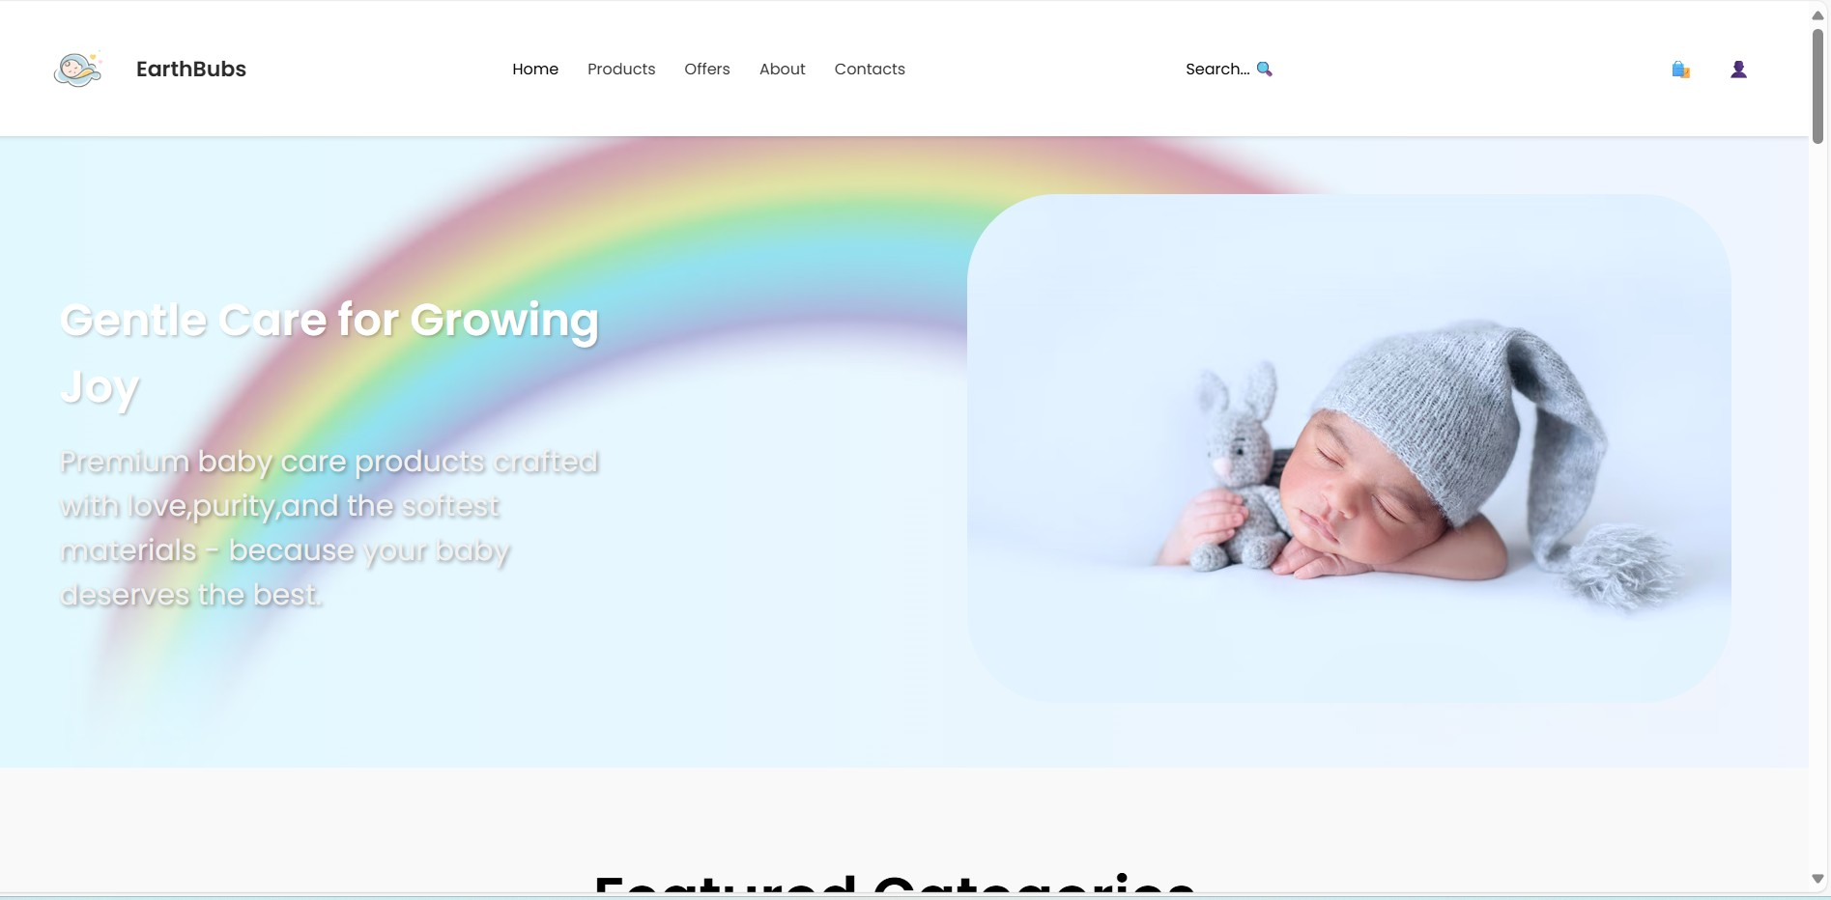

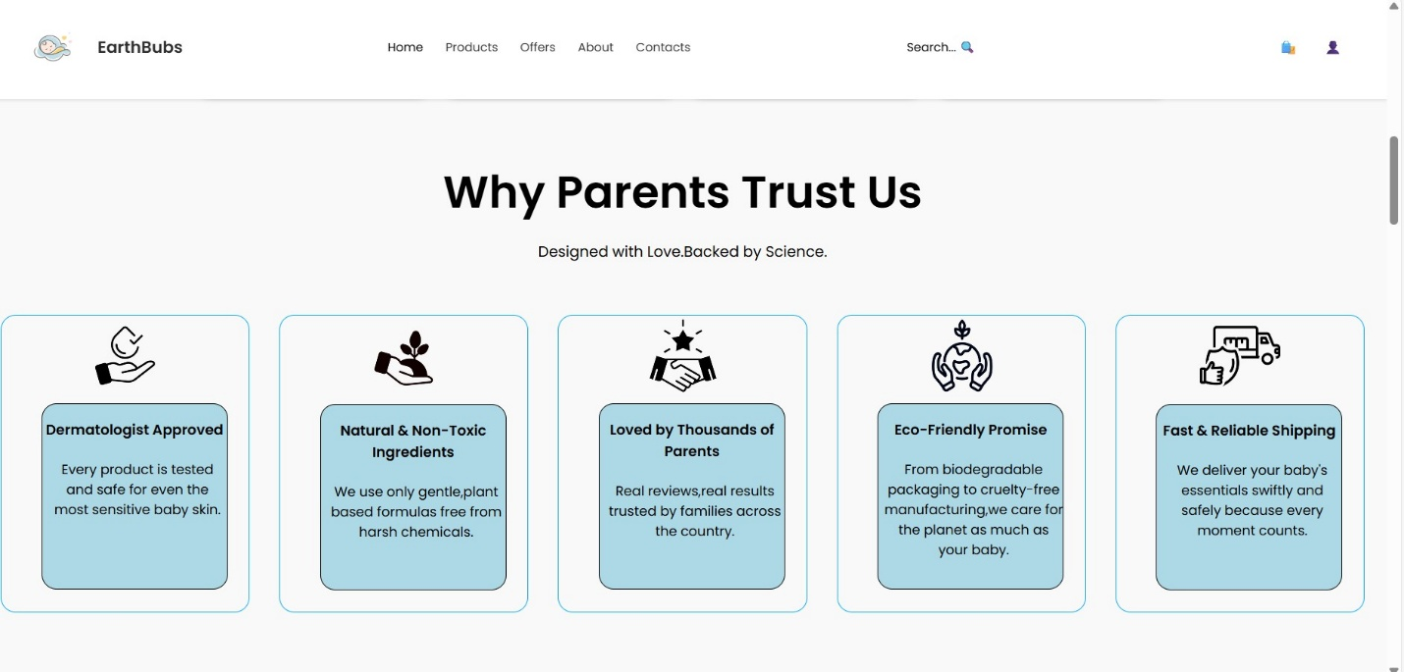

* **Product Page:**

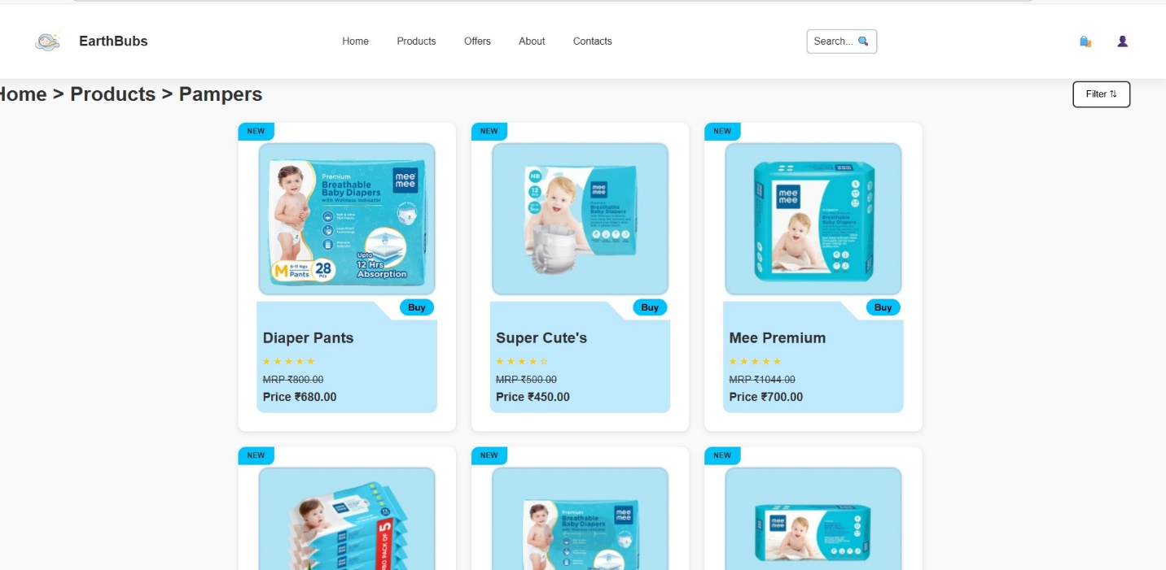

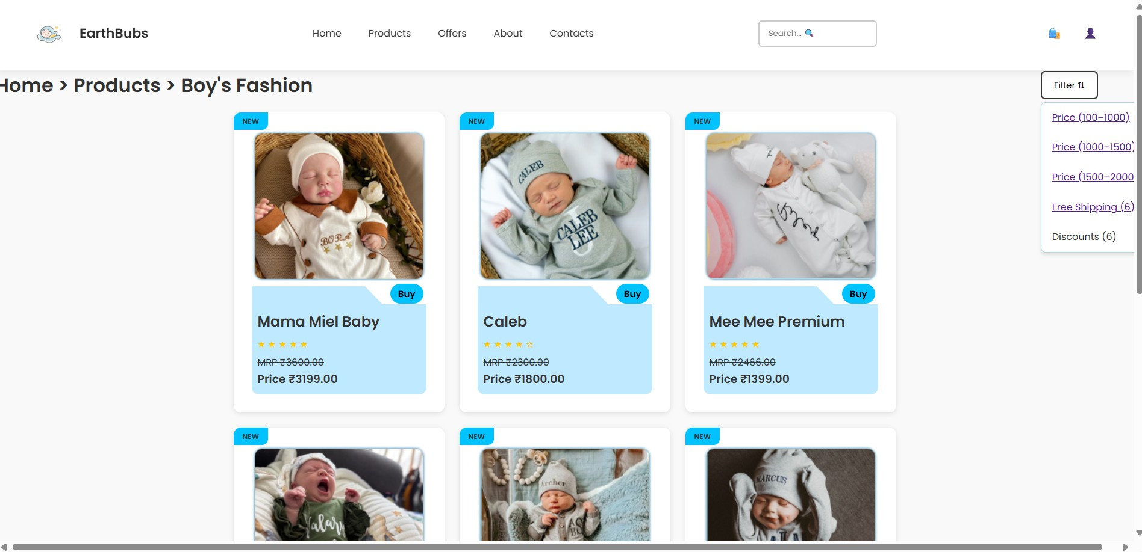

* **About:**

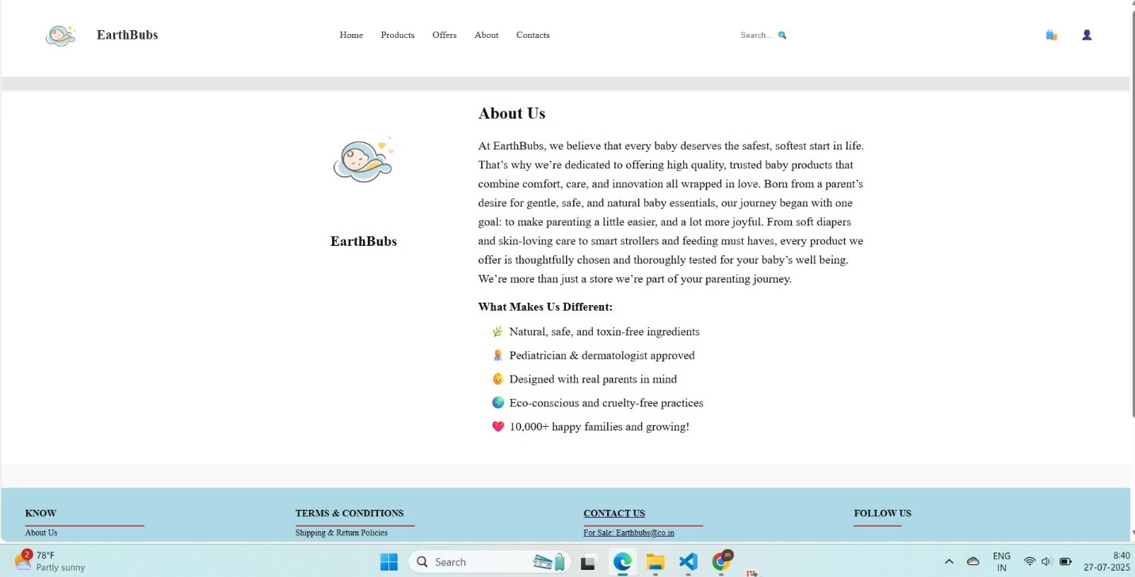

* Contacts:

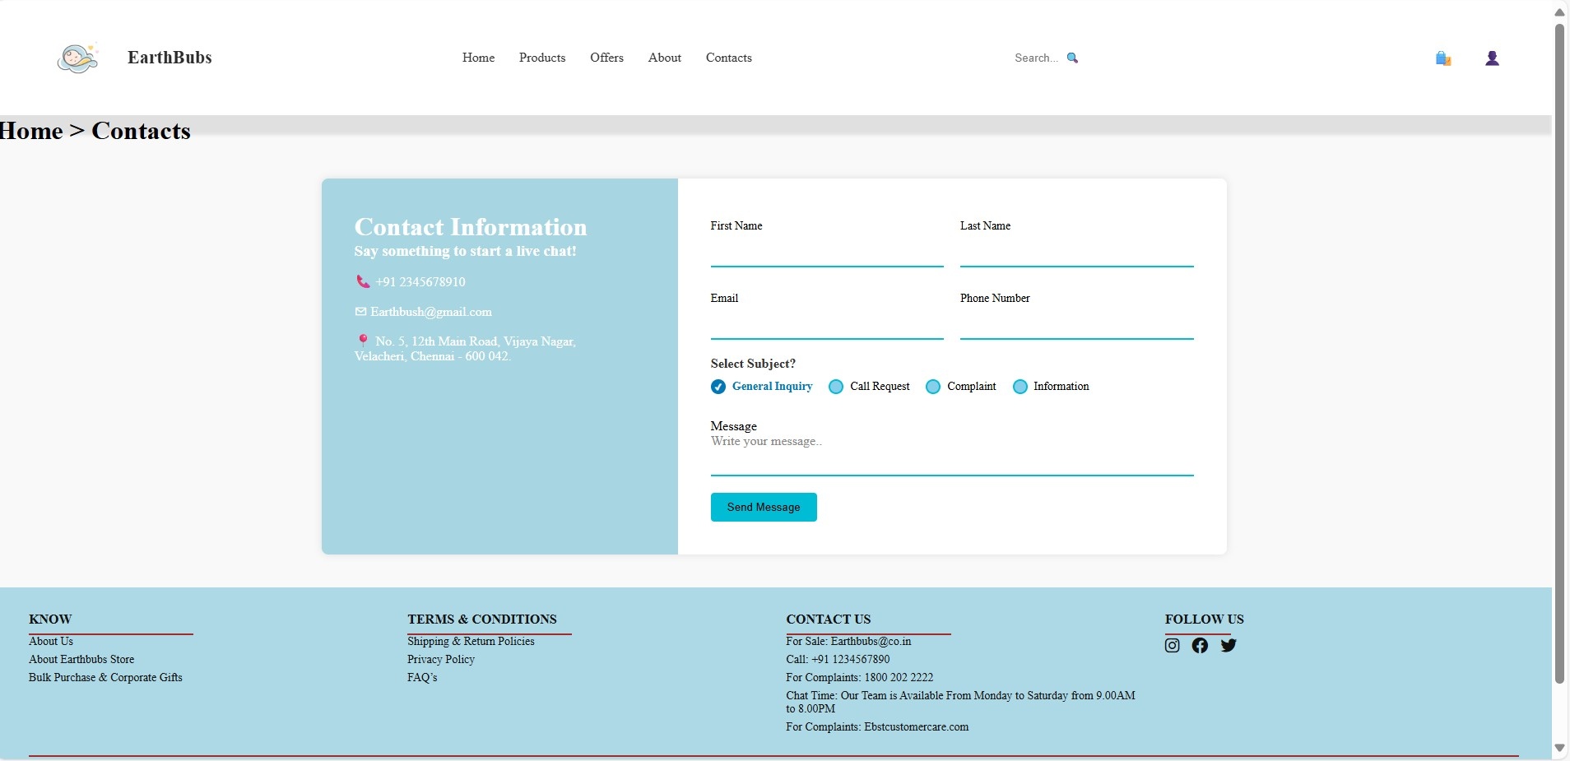

* **Payment:**

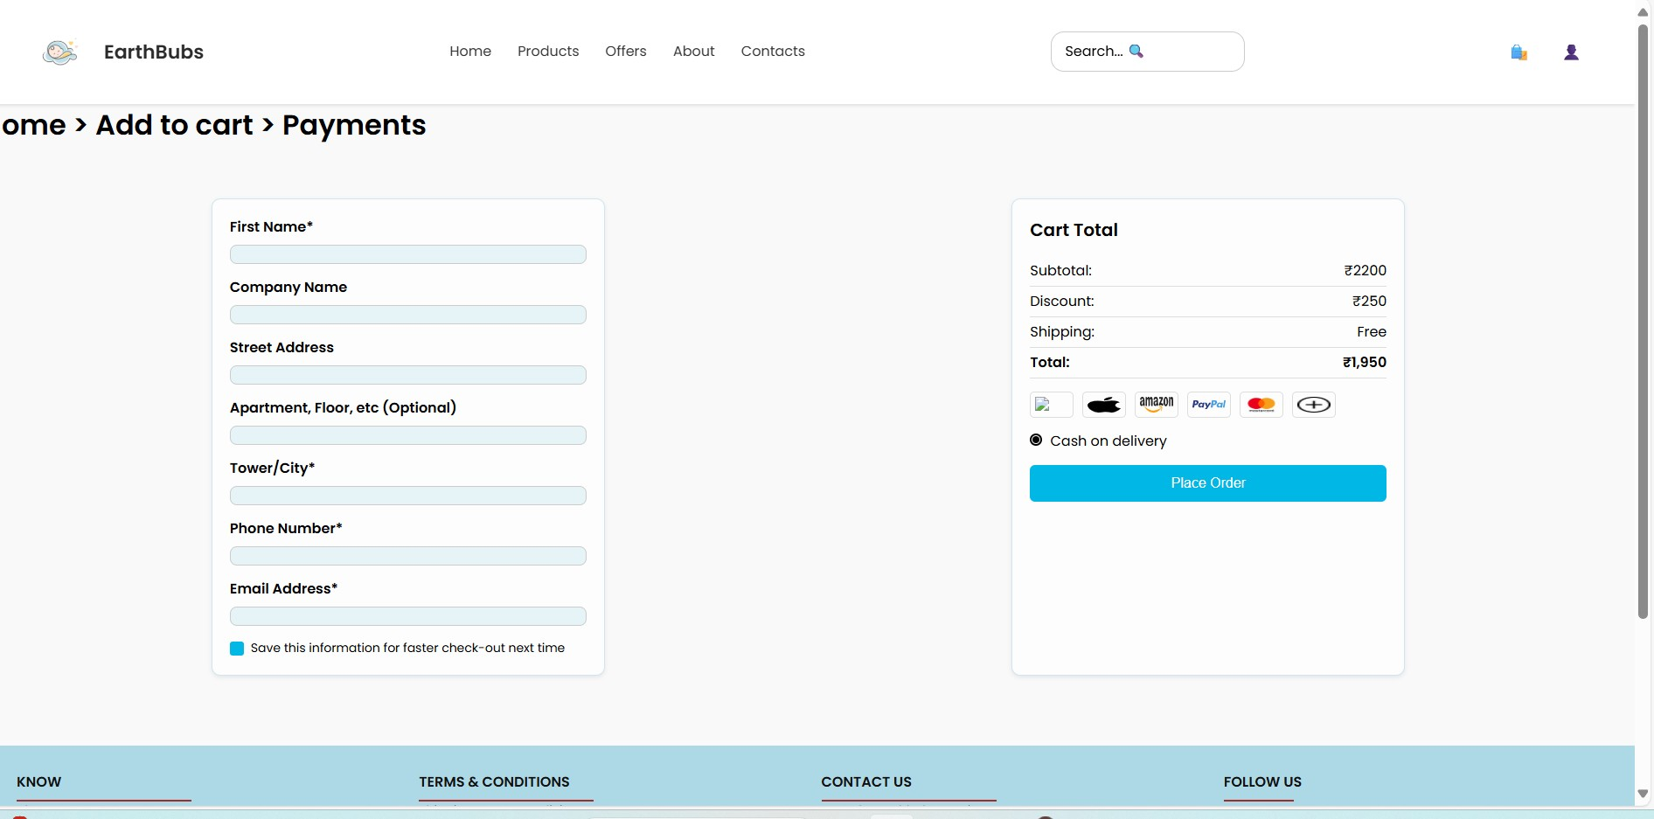

* **Order Summary:**

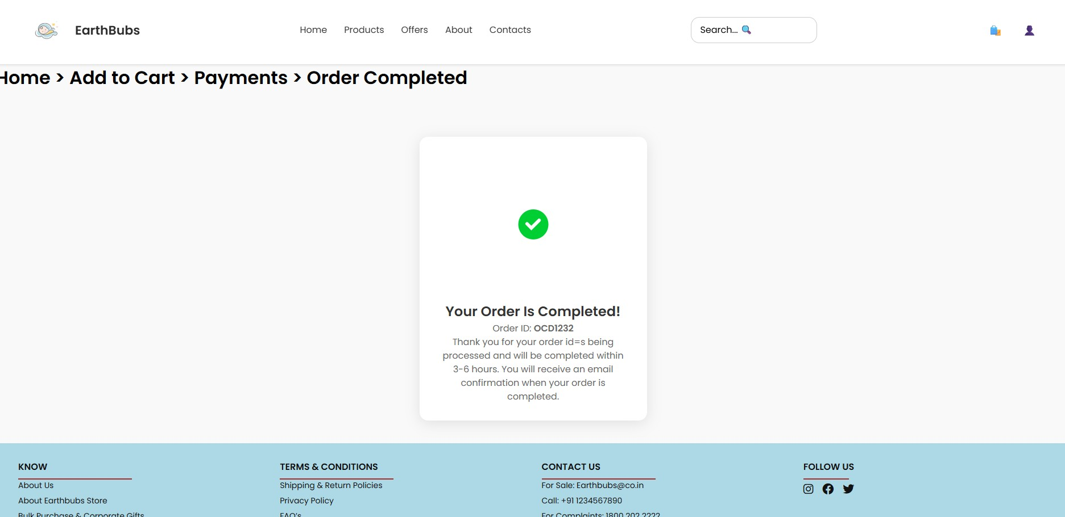

**8. Conclusion**

The Vetri IT systems aims to deliver the **Baby Product Website Design** project provides a modern, responsive, and user-focused interface for showcasing baby care products.  
The design prioritizes **ease of navigation, attractive visuals, and clear CTAs**, ensuring that customers can quickly find and purchase products.

This prototype sets a solid foundation for developing a full-fledged e-commerce platform by focusing on:

* **User experience (UX)** through clean layouts and easy interactions.
* **Sales-driven elements** such as coupon highlights, product ratings, and clear pricing.
* **Scalability**, where future backend integrations (cart logic, payments) can be added seamlessly.

**Prepared By:** Saranyadevi T  
**Date:** 26-07-2025  
**Reviewed By:** Alagu Mari  
**Approved By:** Alagu Mari